Assignment 1

COMP 4107

Group Members: Aidan Crowther

100980915

David N. Zilio  
 100997259

Date: October 7th 2018

# Q1

# Q2

Input matrix: [[1 2 3]

[2 3 4]

[4 5 6]

[1 1 1]]

S: [[-0.33306893 -0.73220483 0.57543613 -0.1476971 ]

[-0.48640367 -0.34110504 -0.56984703 0.56774394]

[-0.79307315 0.44109455 -0.0055891 -0.42004684]

[-0.15333474 0.39109979 0.58661434 0.69239659]]

D: [[1.10528306e+01 0.00000000e+00 0.00000000e+00]

[0.00000000e+00 9.13748280e-01 0.00000000e+00]

[0.00000000e+00 0.00000000e+00 5.00674393e-16]]

VT: [[-0.41903326 -0.56492763 -0.71082199]

[ 0.81101447 0.11912225 -0.57276996]

[ 0.40824829 -0.81649658 0.40824829]]

# Q3

A2:

[[0.17447807 0.17754332 0.18056607 ... 0.18056607 0.17754332 0.17447807]

[0.17754332 0.18059153 0.18359756 ... 0.18359756 0.18059153 0.17754332]

[0.18056607 0.18359756 0.18658718 ... 0.18658718 0.18359756 0.18056607]

...

[0.18056607 0.18359756 0.18658718 ... 0.18658718 0.18359756 0.18056607]

[0.17754332 0.18059153 0.18359756 ... 0.18359756 0.18059153 0.17754332]

[0.17447807 0.17754332 0.18056607 ... 0.18056607 0.17754332 0.17447807]]

||A-A2|| 1.3311896328587207

# Q4

Result using 0.01 :

X = [ 0.08752778556818192 , -0.38961819935275643 , 0.482816086412495 ]

Count = 481

Result using 0.05 :

X = [ -1.6033147267832423e+306 , -2.1615391338127492e+306 , -2.7197635408422558e+306 ]

Count = 433

Result using 0.1 :

X = [ 1.206380722294232e+306 , 1.6264050332451095e+306 , 2.0464293441959872e+306 ]

Count = 292

Result using 0.15 :

X = [ 5.1586078550049535e+306 , 6.954674942054924e+306 , 8.750742029104893e+306 ]

Count = 248

Result using 0.2 :

X = [ 2.315068000058054e+306 , 3.121102797828677e+306 , 3.9271375955992996e+306 ]

Count = 224

Result using 0.25 :

X = [ -6.962180050456917e+306 , -9.38619497739297e+306 , -1.181020990432902e+307 ]

Count = 209

Result using 0.5 :

X = [ -1.764029499880942e+307 , -2.3782098009184467e+307 , -2.992390101955951e+307 ]

Count = 173

# Q5

Rank of the null space matrix is: 2 with 2 columns

Two linearly independent vectors are:

[ 0.8290113 -0.2330726 0.24969281 -0.44279897]

[-0.04453418 0.85004094 0.44341588 -0.28076586]

Pseudo-Inverse for the matrix is:

[[ 0.06507304 0.01460823 -0.05046481]

[ 0.03984064 -0.03187251 -0.07171315]

[-0.00929615 0.14077025 0.1500664 ]

[ 0.09561753 0.12350598 0.02788845]]

# Q6

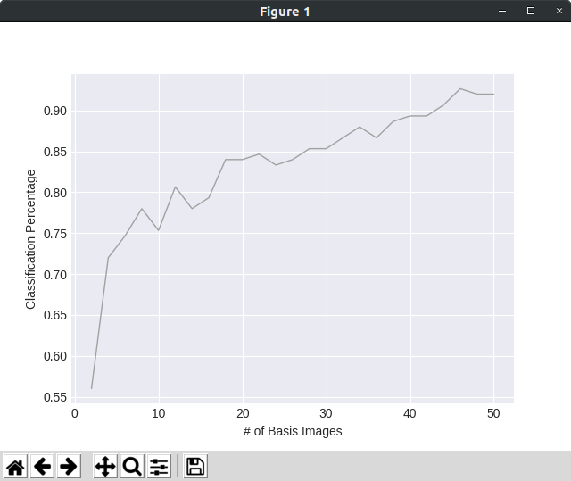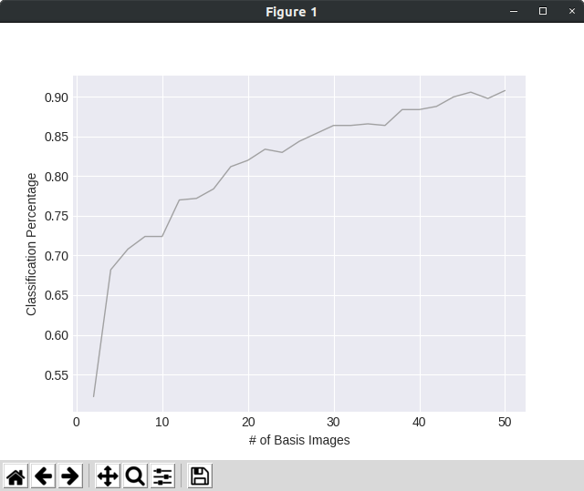Tested against a set of 500 images: Tested against a set of 150images:

# Q7

Asdf